Reduce the hot-spot temperature of an oil transformer using a heat pipe

Mohammad Mustafa Ghafurian¹, Nikan Salahi² and Hamid Niazmand³
¹Assist. Prof., Engineering Faculty, Ferdowsi University of Mashhad, Iran
²B.Sc, Engineering Faculty, Ferdowsi University of Mashhad, Iran
³Prof, Engineering Faculty, Ferdowsi University of Mashhad, Iran
*Corresponding author: hniazmand@yahoo.com
Received: 06/01/2023 Revised: 09/12/2022 Accepted: 05/01/2023

Abstract
Transformers are one of the most significant and sensitive tools in the electrical grid. Their life and optimal operations are very imperative. The hot-spot temperature of this equipment plays a crucial role in the life of the transformer. Increasing hot spot temperature reduces the oil quality and aging of the insulation, ultimately, the life of the transformer. There are several ways to reduce the hot-spot temperature. One of these techniques is the passive cooling system via heat pipe, which has played an effective role in reducing the hot-spot temperature. However, using heat pipes in the space inside the transformer causes problems, including disruption of its electrical performance. Therefore, in this research, the thermal effects of the heat pipe inside and outside the oil tank on the thermal performance of the transformer are investigated experimentally, and finally the obtained results are compared. The results showed that by installing the heat pipes outside the transformer on the radiators, the temperature reduction of the hot spot reached 12 degrees Celsius, which reduces the corresponding aging rate to 0.17.
Keywords: Transformer, Hot-spot temperature, insulation aging, passive cooling, Heat pipe, thermal performance, experimental, radiators

1. Introduction
The correct and desirable operation of the networks depends to a large extent on the performance and lifespan of the transformers [1, 2]. Increasing the temperature of the transformer to the critical temperature ($T_{st}$) or higher, causes damage to the insulation of the winding and reduces the quality of the transformer oil, which ultimately leads to a decrease in the lifespan of the transformer. The load capacity of a transformer is directly related to the cooling performance of a transformer, as with increasing load, the transformer losses (hysteresis losses, eddy current losses, and winding losses) increase, and the temperature of the transformer's hot spot ($T_{ht}$) increases, as a result, the transformer will require more cooling [3, 4].
There has been less consideration given to passive methods for cooling transformers compared to active methods. Therefore, investigating passive methods is appropriate to find new, efficient, and cheaper alternative methods.
One of the passive cooling transformers is the use of heat pipes [5, 6]. As an example, Rosas et al [7] investigated the hot spot temperature in an ONAN transformer using a heat pipe. Their results showed that up to 20% of the generated heat (transformer losses) could be transferred by installing two thermosyphon heat pipes on top of the transformer. Dutai et al [8] modeled the losses of a power transformer using the heat generated by a 25 kW heating element around a thermosyphon heat pipe. The heat pipe had an outer diameter of 16 mm, an evaporator length of 210 mm, and a condenser length of 750 mm, and was made of two materials, aluminum and steel, with acetone as the working fluid. Their results showed that the aluminum heat pipe had better performance. In this study, they only focused on the performance of the heat pipe and did not conduct any thermal study on the transformer. In another study, Niu et al [9] experimentally studied the performance of a thermosyphon heat pipe in dissipating the losses of a dry-type laboratory transformer. In this study, 24 copper thermosyphon heat pipes with water as the working fluid were used inside the transformer, along with two loop heat pipes with fluorocarbon as the working fluid outside the transformer. Their results showed that the designed system was able to effectively reduce the increase in air temperature in the upper layers of the tank. However, the complexity of installing heat pipes among the active components in this system was one of its challenges, as two types of heat transfer systems were used. In another study, this group [10] evaluated the thermal performance of a 2500-watt oil-immersed transformer using a simple heat pipe. The heat losses were supplied by three 850-watt heaters and dissipated through a loop heat pipe with fluorocarbon as the working fluid. The evaporator of the loop heat pipe was a 16 mm diameter, 500 mm long pipe located inside the oil and close to the tank walls, and the cooling action of the heat pipe condenser was performed by a radiator. As observed in previous studies, simple heat pipes play an effective role in improving the cooling system of transformers. However, none of these studies have paid attention to the location of these devices, as one of the problems with this mechanism is its proximity to active components. Installing heat pipes inside transformer compartments creates problems such as electrical discharge and disturbance in electric and magnetic fields, which will reduce the proper performance of transformers in the long run. On the other hand, recent studies on heat pipe technology, especially sintered heat pipes, in transformer cooling systems with maintaining performance are considered one of the gap in this field. Therefore, this study focuses on experimental studies of the performance of a laboratory transformer and the thermal effects of heat pipes inside and outside the oil tank. For this purpose, the performance of a single

transformer (Tra) with two sintered heat pipe models under different conditions, including a transformer with a heat pipe on it (Tra-Hp), a transformer with a radiator (Tra/Hx), a transformer with a heat pipe on it and a radiator (Tra-Hp/Hx), and a transformer with a heat pipe on a radiator connected to it (Tra/Hx-Hp), are studied. Finally, the performance of the system is compared to introduce the best approach.

2. Methodology
The laboratory setup used in this study includes a 5-liter capacity laboratory transformer that can provide the thermal performance conditions of a real transformer under full and partial loads. Additionally, the laboratory setup includes a seven-tube radiator with a volume of 1.5 liters designed to accommodate heat pipes inside it similar to real transformer radiators. This setup is capable of being placed under different loads by adjusting the voltage, and in this article, all tests were conducted under approximately the same heat flux of 1750 W.
In all tests, the system was placed on a metal stand at a height of 1.5 meters from the ground to provide similar operating conditions to a real transformer for conducting experiments. The oil used in the transformer is ordinary mineral oil (MO) commonly used in large power transformers. Two straight heat pipes with, filled with water as the working fluid and 60% filling ratio, with a length and diameter of 300 and 10 millimeters, respectively, made in China were used to investigate their performance in transformer cooling. The length of the evaporator section is 80 millimeters, the length of the insulation section is 120 millimeters, and the length of the condenser section is 100 millimeters. Ten DS18B20 temperature sensors with an accuracy of 0.5 degrees Celsius were used to report the temperature of different points of the transformer oil in the fins, their bases, as well as one sensor to report the ambient temperature of the transformer. $T_{LH,f}$,$T_{LM,f}$, and $T_{LL,f}$ sensors measure the oil temperature in the longitudinal direction of transformer fins, while $T_{RH}$, $T_{RM}$, and $T_{RL}$ sensors measure the oil temperature in different heights in the longitudinal direction of the transformer tank. $T_{WH}$ and $T_{WL}$ sensors measure the oil temperature in the transverse section of the transformer. Additionally, two sensors, $T_{HL}$ and${ T}_{HR}$, are placed on the top of the transformer tank to measure the hot spot temperature. The $T_{amb}$ sensor is also used to measure the ambient temperature, placed 40 centimeters away from the transformer to reduce the effects of heat transfer from the transformer on the sensor.
To ensure the approximate stability of the ambient temperature trend, as well as wind gusts and sunlight intensity, all tests were performed on consecutive days and at specific times. For this purpose, all measurements were taken for 5 hours between 10 am to 3 pm. The tests were conducted by placing the transformer under different conditions, including the transformer alone (Tra), using a heat pipe on the transformer (Tra-Hp), using a radiator (Tra/Hx), using a heat pipe on the transformer with a radiator connected to it (Tra-Hp/Hx), and using a heat pipe on the radiator connected to the transformer (Tra/Hx-Hp). All experiments were conducted in a closed laboratory environment to minimize environmental effects.

3. Discussion and Results
To investigate the passive cooling methods mentioned in the experimental procedure section, the laboratory setup was first tested under load in the laboratory environment in its base state (Tra). This test was used as a reference test, and the effects of different methods on the hot spot temperature of the transformer will be examined and compared. The maximum temperature of 63.4 degrees Celsius was recorded by the $T_{HL}$ sensor in this test, which actually increased the hot spot temperature by about 45.9 degrees Celsius from the start of the test to the stability time. Additionally, the $T_{amb}$ sensor, which indicates the ambient temperature, varied between 15.4 to 17.5 degrees Celsius during the test period. Considering that all tests were performed on consecutive days and the ambient temperature was almost constant, this temperature range can be generalized to all tests' environments. Figure 1 shows the absolute temperature results of the transformer test with a heat pipe installed on the radiator (Tra/Hx-Hp). Although the experiments were conducted in a controlled laboratory environment, the temperatures are reported based on the temperature difference of the sensors from the environment sensor ($T_{amb}$) for a more logical comparison of the results.

Figure1. Absolute temperatures of transformer sensors in Tra/Hx-Hp condition
(a)

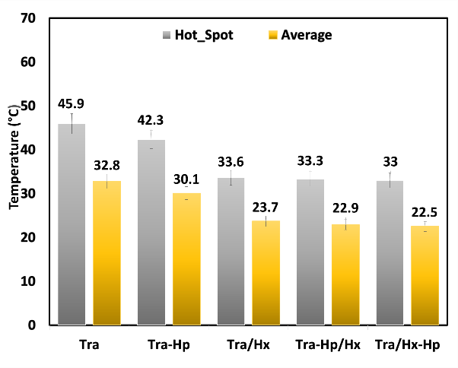
Continuing with a better comparison of the hot spot temperature effect in different applications of the heat pipe in the transformer, Figure 2 (a) and (b) show the average bulk oil temperature of the transformer and the percentage of the cooling methods effect tested on reducing the hot spot temperature compared to the base state.
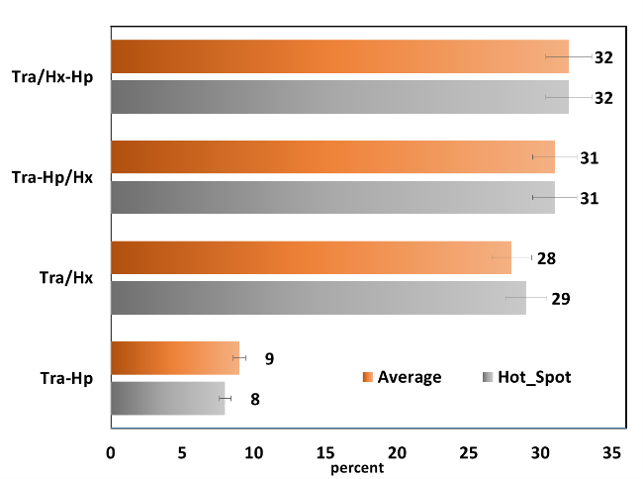
(b)
Figure2. (a) Hotspot and averaged relative temperature of different points of transformer (b) The percentage of the effect of different tested cooling methods on the relative hot spot temperature and the relative top oil temperature compared to the base state (Tra).

By comparing the results for two different installation methods of a heat pipe on a transformer with a radiator (Tra-Hp/Hx) and installing a heat pipe on a radiator (Tra/Hx-Hp) with the state of no heat pipe (Tra/Hx), it can be observed that placing a heat pipe in the radiator can create a temperature reduction of approximately 0.3 degrees Celsius compared to installing the heat pipe on the transformer with a radiator. On the other hand, based on figure 2, it can easily be observed that installing a heat pipe on a radiator (Tra/Hx-Hp) and away from active components not only does not reduce the performance of the heat pipe compared to installing the heat pipe on the transformer with a radiator (Tra-Hp/Hx), but it can also cause a partial improvement in cooling. The reason is the lower temperature of the heat pipe condensers, which are located further away from the hotter points of the transformer.

4. Conclusion
This study investigated the experimental methods of non-active transformers with heat pipes (Tra-Hp), transformers with radiators (Tra/Hx), transformers with radiators and heat pipes installed on them (Tra-Hp/Hx), and transformers with radiators and heat pipes installed on the radiators (Tra/Hx-Hp). All tests were conducted under laboratory conditions and with the same load. The results showed that the transformer methods with heat pipes (Tra-Hp), radiators (Tra/Hx), radiators with heat pipes installed on the transformer (Tra-Hp/Hx), and radiators with heat pipes installed on the radiators (Tra/Hx-Hp) reduced the relative hot spot temperature compared to the base transformer state (Tra) by 7.8%, 26.8%, 27.5%, and 28.1%, respectively. With the least effective method (T-Heat Pipe), the transformer lifespan can be increased by about 38% according to the increase in the insulation paper lifespan. Furthermore, it was observed that by removing the heat pipe from the transformer compartment and installing it on the radiator, not only does it not reduce the performance of the heat pipe, but it also improves the cooling of the transformer.

5. References
[1] Kulkarni SV, Khaparde SA. Transformer engineering: design, tech & diag: CRC press; 2017.
[2] Sefidgaran M, Mirzaie M, Ebrahimzadeh A. Reliability model of the power transformer with ONAF cooling. Elec. Power & Energy Sys. 2012; 35:97-104.
[3] S. Anishek, R. Sony, J. J. Kumar, and P. M. Kamath, "Performance analysis and optimisation of an oil natural air natural power transformer radiator," Procedia Tech., vol. 24, pp. 428-435, 2016.
[4] M. Pradhan and T. Ramu, "Prediction of hottest spot temperature (HST) in power and station transformers," IEEE Transactions on Power Delivery, vol. 18, no. 4, pp. 1275-1283, 2003.
[5] M. Shojai Far, J. Zare, M. Tahani (2013) Investigation and comparison of different nanofluids effects on heat pipe thermal performance. Structural & Fluid Mech., 3(3), 83-95.
[6] K.S. Abad, M. Shafiee, T.Rahni, M. Abbaspour (2013) Experimental investigation of using oscillating heat pipes in large scale flat plate solar collectors. Structural & Fluid Mech., 2(1), 57-66.
[7] C. Rosas, N. Moraga, V. Bubnovich, and R. Fischer, "Improvement of the cooling process of oil-immersed electrical transformers using heat pipes," IEEE transactions on power delivery, vol. 20, no. 3, pp. 1955-1961, 2005.
[8] M. Dutai, D. Popescui, and D. Fetcu, "Cooling equipment with heat pipes for power transformers reliability improvement," Int. Conf. on Hyd. & Pneumatics, 2016.
[9] W. Niu, G. Zhang, and H. Zhong, "Preliminary study of a relay transmitted cooling system with heat pipes and LHP system in large capacity gas insulated transformers," in 2014 17th Int. Conf. on Elec. Machines and Sys (ICEMS), 2014: IEEE, pp. 2332-2335.
[10] W. Niu et al., "Experimental study of the evaporative cooling system in a low-noise power transformer," in 2012 China Int. Conf. on Electrical Distribution, 2012: IEEE, pp. 1-4.

