Experimental investigation of the formability of heat-treated AA6063 tubes using hydraulic rotary draw bending process

Majid Elyasi¹, Vahid Modanloo^{2*}, Farzad Ahmadi Khatir³, Hossein Talebi Ghadikolaee⁴
¹ Assoc. Prof., Mechanical Engineering Department, Babol Noshirvani University of Technology, Babol, Iran
² Assist. Prof., Mechanical Engineering Department, Sirjan University of Technology, Sirjan, Iran
³ Assist. Prof., Mechanical Engineering Department, Semnan University, Semnan, Iran
⁴ Assist. Prof., Mechanical Engineering Department, University of Kashan, Kashan, Iran
*Corresponding author: v.modanloo@sirjantech.ac.ir
Received: 05/31/2023 Revised: 07/19/2023 Accepted: 09/19/2023

Abstract
In this paper, formability of thin-walled aluminum tubes has been investigated using the hydraulic rotary draw bending process. First, AA6063 tubes with a ratio of diameter to thickness of 13.88, and outer diameter of 25 mm were subjected to annealing and artificial aging heat treatments. Then, bending experiments were performed on as-received and heat-treated samples at fluid pressures of 0, 1, 1.8, 3.2, and 3.6 MPa. After performing the experiments, the amount of thinning and thickening of the bent tubes were measured. The obtained results showed that for all samples, the maximum thinning and thickening occur at an angle of 40 degrees to the pressure die. Also, the heat treatment and the fluid pressure have interaction effects, so the effect of the heat treatment is not very noticeable at the pressure of 0 MPa, but its effect is remarkable at the maximum pressure of 3.6 MPa. At maximum fluid pressure, the thinning reduces by 7% under aging heat treatment and with annealing heat treatment, the thinning increases by 13% compared to the as-received sample. In addition, compared to the as-received sample, the thickening of aged tubes increases by 5% and decreases by 16%, respectively.

Keywords: Tube Bending, Heat Treatments, Formability, Maximum Fluid Pressure.

- Introduction
Tube bending as one of the forming processes is widely used in various industries such as aerospace, automotive, and medical [1]. Manufacturing bent tubes with complex shapes and high precision is very important [2]. There are different methods for tube bending including press bending, roll bending, laser bending, rotary draw bending, and hydraulic rotary draw bending [3-7]. Among the mentioned methods, hydraulic rotary draw bending has received much attention from researchers in recent years. Due to the application of internal fluid pressure, this method has some advantages such as high accuracy, less springback, more uniform thickness distribution, producing bends with good quality, and the possibility of controlling the material flow in the bending zone compared to other tube bending methods [8, 9]. Aluminum alloys are extensively used in automotive and aerospace industries due to their advantages including high formability and good corrosion resistance. Among aluminum alloys, the 6xxx series can be hardened through the precipitation hardening process. AA6063 is one of the most applicable alloys in which magnesium, manganese, and silicon are the primary additive elements that lead to an increase in mechanical strength and corrosion resistance. There are different types of aluminum heat treatments. Annealing and artificial aging are among the most commonly used heat treatments that result in the enhancement of ductility and strength of the metallic material, respectively [10-13].
In this paper, the formability of the heat-treated AA6063 tubes is experimentally studied via the hydraulic rotary draw bending process. First, as-received AA6063 tubes with a (D/t) ratio of 13.88, outer diameter of 25, and thickness of 1.8 mm are subjected to annealing and artificial aging heat treatments. Then, the hydraulic rotary draw bending experiments will be performed on the different tubes at various fluid pressures of 0, 1, 1.8, 3.2, and 3.6 MPa. Finally, the value of thinning, thickening, and ovality of the bent samples are measured. The effect of heat treatment and fluid pressure on the bending behavior of the heat-treated tubes will be determined and discussed.

- Experimental procedure
In this paper, AA6063 tubes were used to perform hydraulic rotary draw bending experiments. Table 1 shows the geometrical characteristics of the tube and used die. Figure 1 illustrates the components of the used hydraulic rotary draw bending device. The MO40 material was used to manufacture the bending die. Also, the SAE20W50 oil was used as a pressure medium while the die components were fully sealed. The tubes were heated to a temperature of 415 °C for three hours and slowly cooled in the furnace for homogenization to obtain annealing conditions. Also, the tubes were heated for one hour at the temperature of 520 °C in the furnace and were immediately quenched in cold water to obtain artificial aging conditions. Then, the samples were heated for eight hours at 175 °C. To evaluate the mechanical properties of the different heat-treated tubes; as-received, annealed, and artificial aged, tensile tests were carried out through a SANTAM press machine with 250 kN capacity based on the ASTM-A370 standard. After bending experiments, the bent tubes were cut using wire EDM to analyze their quality. Eqs. (1) to (3) were used to measure the thinning, thickening, and ovality of the various tubes, respectively [14]. In these equations, $D_{max}$, $D_{min}$, $t_{0}$, $t_{min}$, and $t_{max}$ denote the maximum and minimum tube diameter after bending, initial thickness, minimum, and maximum thickness after bending, respectively. To investigate the effect of fluid pressure on the formability of the various tubes, 15 experimental tests were carried out at pressures of 0, 1, 1.8, 3.2, and 3.6 MPa. The internal fluid pressures were selected based on the preliminary tests with respect to the rupture pressure of the tubes.

Table 1. Geometrical characteristics of the AA60603 tube and bending die
Value (unit) | Parameter
1.8 (mm) | Thickness
25 (mm) | Outer diameter
13.88 | D/t ratio
90 (deg) | Bending angle
40 (mm) | Bending radius
1.6 | R/t ratio

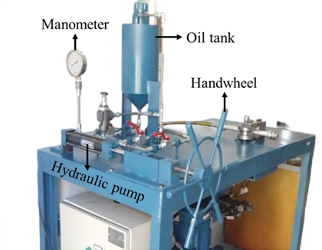
Figure 1. The components of the used hydraulic rotary draw bending device

(1) | $$Thinning (\%)=\frac{t_{0}-t_{min}}{t_{0}}×100$$

(2) | $$Thickening (\%)=\frac{t_{max}-t_{0}}{t_{0}}×100$$

(3) | $$Ovality (\%)=\frac{D_{max}-D_{min}}{{D_{max}+D_{min}}/2}×100$$

- Results and Discussion
After performing the bending experiments for various tubes at different fluid pressures, it was found that in all cases the maximum thinning and thickening occurs at an angle of 40$°$. As a result, this angle was considered as the critical angle. The comparison of the critical thinning and thickening for various tubes (as-received, annealed, and artificial aged) at different fluid pressures is shown in Table 2. As can be seen, the lowest thinning with a value of 6.12% corresponds to experiment number 3 in which the aluminum tube is subjected to artificial aging heat treatment and the fluid pressure is 0 MPa. Also, the highest thinning is related to experiment number 14, in which the tube is subjected to annealing heat treatment and the internal fluid pressure is 3.6 MPa. For the thickening output, the minimum (19.41%) and maximum (32.67%) values correspond to experiments number 14 and 3, respectively. In these experiments, the tubes are annealed and artificial aged, respectively. Also, Figure 2 shows the ovality of the various tubes at the minimum (0 MPa) and the maximum (3.6 MPa) fluid pressures. As is shown, regardless of the fluid pressure, the lowest ovality occurs in the annealed tube which is caused by the increase in ductility. At the pressure of 3.6 MPa, the ovality rate for the as-received, annealed, and aged tubes was obtained at 10.15, 8.77, and 10.72%, respectively. Also, at the fluid pressure of 0 MPa, the ovality of the as-received, annealed, and aged tubes was obtained at 18.54, 17.30 and 19.85%, respectively. By examining the results, it was found that in the optimal bending condition i.e. annealing heat treatment and a fluid pressure of 3.6 MPa, the amount of ovality decreases by about 49%.

Table 2. Comparison of thinning and thickening for various tubes at different fluid pressure
Thickening (%) | Thinning (%) | Pressure (MPa) | Tube  type | Test no,
32.18 | 6.66 | 0 | As-received | 1
31.45 | 6.95 | 0 | Annealed | 2
32.67 | 6.12 | 0 | Aged | 3
29.89 | 10.25 | 1 | As-received | 4
28.71 | 10.7 | 1 | Annealed | 5
31 | 9.74 | 1 | Aged | 6
27.59 | 13.84 | 1.8 | As-received | 7
25.97 | 14.44 | 1.8 | Annealed | 8
29.32 | 13.36 | 1.8 | Aged | 9
24.86 | 15.55 | 3.2 | As-received | 10
22.08 | 16.65 | 3.2 | Annealed | 11
26.23 | 14.49 | 3.2 | Aged | 12
23.24 | 16.68 | 3.6 | As-received | 13
19.41 | 18.84 | 3.6 | Annealed | 14
24.41 | 15.52 | 3.6 | Aged | 15

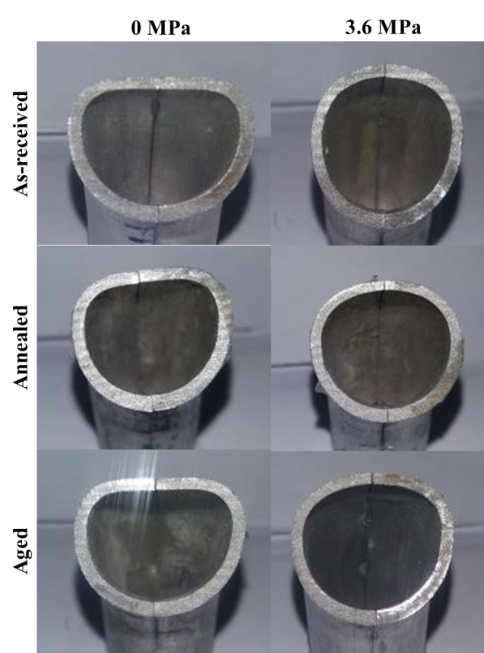
Figure 2. The ovality of the various tubes at minimum and maximum fluid pressures

- Conclusions
In this paper, the effect of annealing and artificial aging heat treatments on the formability behavior of the AA6063 tubes was experimentally investigated using the hydraulic rotary draw bending process. Different fluid pressures of 0, 1, 1.8, 3.2, and 3.6 MPa were used to perform the bending experiments. The obtained results showed that:
      - Maximum thinning and thickening for all tubes (as-received, annealed, and artificial aged) at all fluid pressures occur at an angle of 40$°$.

      - An increase in fluid pressure leads to an increase in the thinning of the various tubes in all cases. At the highest fluid pressure, i.e. 3.6 MPa, the highest thinning belongs to the annealed tube by 18.84% and the lowest thinning belongs to the aged tube by 15.52%.

      - An increase in fluid pressure leads to a decrease in the thickening of the various tubes in all cases. At the maximum fluid pressure, the minimum thickening (19.41%) belongs to the annealed tube and the maximum thickening (24.41%) belongs to the aged tube.

- References
[1] Taghizadeh Rami F, Elyasi M (2022) Improvement of rotary draw bending of commercial pure titanium tubes with resistance deformation and using steel ball. Modares Mech Eng 22(6):371-380.
[2] Elyasi M, Modanloo V, Talebi Ghadikolaee H, Ahmadi Khatir F, Akhoundi B (2023) Investigating the effect of heat treatment in hydraulic rotary draw bending of AA6063 tubes. Modares Mech Eng 23(4):257-264.
[3] Nakajima K, Utsumi N, Yoshida M (2013) Suppressing method of the cross section deformation for extruded square tubes in press bending. Int J Prec Eng and Manu 14:965-970.
[4] Wang A, Xue H, Saud S, Yang Y, Wei Y (2019) Improvement of springback prediction accuracy for Z-section profiles in four-roll bending process considering neutral layer shift. J Manu Proc 48:218-227.
[5] Safari M (2020) A study on the laser tube bending process: Effects of the irradiating length and the number of irradiating passes. Iran J Mater Form 7(1):46-53.
[6] Ashtiani HR, Moghaddam S (2022) Experimental and Numerical Investigation on the Heat Treatment Effects of AA6063 Aluminum Alloy Tubes during Rotary Draw Bending. Iran J Mater Sci and Eng 19(1):1-14.
[7] Elyasi M, Paluch M, Hosseinzadeh M (2017) Predicting the bending limit of AA8112 tubes using necking criterion in manufacturing of bent tubes. The Int J Adv Manu Tech 88:3307-3318.
[8] Zardoshtian A, Sabet H, Elyasi M (2018) Improvement of the rotary draw bending process in rectangular tubes by using internal fluid pressure. The Int J Adv Manu Tech 95:697-705.
[9] Roein M, Elyasi M, Mirnia MJ (2021) Introduction of a new method for bending of AISI 304L stainless steel micro-tubes with micro-wire mandrel. J Manu Proc 66:27-38.
[10] Baghdadi AH, Rajabi A, Selamat NF, Sajuri Z, Omar MZ (2019) Effect of post-weld heat treatment on the mechanical behavior and dislocation density of friction stir welded Al6061. Mater Sci and Eng: A 754:728-734.
[11] Baruah M, Borah A (2020) Processing and precipitation strengthening of 6xxx series aluminium alloys: A review. Int J Mater Sci 1(1):40-48.
[12] Fiocchi J, Tuissi A, Biffi CA (2021) Heat treatment of aluminium alloys produced by laser powder bed fusion: A review. Mater & Des 204:109651.
[13] Emadi M, Beheshti H, Heidari-Rarani M, Aboutalebi FH (2019) Experimental study of collapse mode and crashworthiness response of tempered and annealed aluminum tubes under axial compression. J Mech Sci and Tech 33:2067-2074.
[14] Modanloo V, Elyasi M, Talebi Ghadikolaee H, Ahmadi Khatir F, Akhoundi B (2023) The use of MCDM techniques to assess fluid pressure on the bending quality of AA6063 heat-treated tubes. J Eng Res.

